The following table represents issues and their frequency:

|  |  |
| --- | --- |
| ISSUES | FREQUENCY |
| Blockchain | 3727 |
| Ico | 3307 |
| Fintech | 771 |
| Jobs | 725 |
| Fraud | 530 |
| thinking | 153 |
| China | 125 |

Lift Values

|  |  |
| --- | --- |
| Word Pair | Lift Value |
| bitcoin_china | 1.390202728 |
| bitcoin_fintech | 1.243619973 |
| bitcoin_thinking | 1.475451008 |
| ethereum_ico | 1.547232361 |
| ethereum_blockchain | 1.145368275 |
| ethereum_job | 1.258253867 |

Based on the lift values calculated, the 3 issues for Bitcoin are Fintech, Thinking and China and 3 issues for Ethereum are Fintech, Ico and Blockchain.

|  |  |
| --- | --- |
|  | **Sentiment** |
| Fintech(Bitcoin) | Negative |
| Thinking(Bitcoin) | Negative |
| China(Bitcoin) | Negative |
| Fintech (Ethereum) | Negative |
| Ico(Ethereum) | Positive |
| Blockchain (Ethereum) | Positive |

Fintech- Financial technology companies

iCO- Initial coin offering

Sentiment about bitcoin in US and the rest of the world:

|  |  |  |
| --- | --- | --- |
|  | Bitcoin | Ethereum |
| USA | Positive | Positive |
| Rest of the world | Positive | Positive |

**BAR GRAPHS**

**Bitcoin and China (sentiment compounded)**

**Sentiment value = -3.7165**

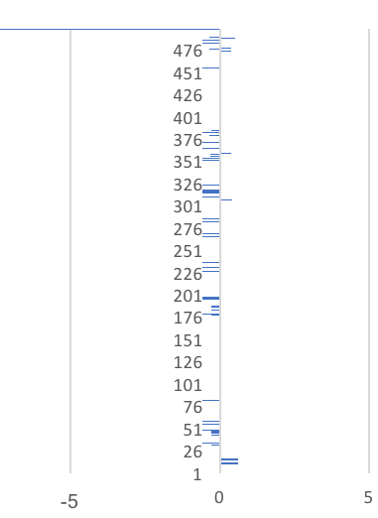

**Bitcoin and Fintech**

**Sentiment value = -19.08**

**Bitcoin and Thinking**

**Sentiment Value= -0.8**

**Ethereum and Blockchain**

**Sentiment value= 96.7**

**Ethereum and Ico**

**Sentiment value= 108.7**

**Ethereum and Fintech**

**Sentiment Value = -25.52**

**Ethereum and USA**

**Sentiment value= 1.1528**

**Ethereum and Rest of the world**

**Sentiment Value= 102.2**

**Bitcoin and USA**

**Sentiment Value= 7.51**

**Bitcoin and Rest of the world**

**Sentiment value= 110.45**

**ANALYSIS**

**Bitcoin**

* Negative sentiments with China is the indication of the recent ban on cryptocurrency by the country. Speculations are that China might be threatened that bitcoin may damage the monetary system of the country. If the concept of blockchain and cryptocurrency are properly explained to the decision makers of the country then the ban can be stopped. Being the country with the largest population and a fast-growing GDP, China has the power to make or break bitcoin to a certain extent.
* People are thinking about bitcoin in a negative sense and are talking about giving up or rejecting it. Make your own way has led to an increase in new cryptocurrencies and that is making the people investing ion bitcoin fee threatened. Understand and evaluate your competitors and increase awareness about advantages of bitcoin.

**Ethereum**

* Crowdsale is a concept that is being appreciated by the people when it comes to ICO (Initial Coin Offering). This should be continued and common people should be involved in raising the money. Recent success of coin offering has increased positivity towards the brand and this must be maintained by their future ventures. This success has made people hopeful that ethereum will be a success and that its prices will increase soon providing profit to the ICO customers. Concept of make your own way i.e. make your own bitcoin is popular right now increasing ethereum’s popularity.
* Awareness regarding the concept of blockchain is increasing and it is being appreciated. The risk sharing and insurance factors are the key points and must be continued and further enhanced to provide a sense of safety and to encourage people to invest in ethereum.

**Bitcoin and Ethereum**

* Negative sentiments have emerged for bitcoin and ethereum when it comes to financial technology. These sentiments are a result of fraud and hacking that have resulted in loss of thousands of dollars for some investors. The system should be made more secure and measures should be taken to prevent fraud. Some companies like Exante provide you a platform with access to 50 markets and 45000 financial products, thus making the trading a lot safer.
* Sentiments shown towards bitcoin and ethereum by USA and the rest of the world are positive but when tweets with a negative score are examined, it is seen that people are concerned about the risk involving investment in cryptocurrency, so awareness about the risk sharing and increasing investments in cryptocurrency must be spread. Hacking is another major concern among the investors or potential investors, practices like online trading platforms must be introduced to decrease the risk of fraud and hacking.